**VISVESVARAYA TECHNOLOGICAL UNIVERSITY**

**JNANA SANGAMA, BELAGAVI -590018**



**MINI-PROJECT (BEC586) REPORT**

**On**

**“RGB COLOUR PICKER”**

**Submitted in partial fulfillment of the requirements for the award of the degree**

**BACHELOR OF ENGINEERING**

**IN**

**ELECTRONICS AND COMMUNICATION**

**Submitted by**

**NAME**

**USN**

**KANCHAN KUMARI 1MV22EC063**

**SHRIYAM 1MV22EC106**

**VAISHNAVI VANI 1MV22EC121**

**Under the Guidance of**

**Dr SUNDARAGURU R**

**Professor / Dept. of ECE**



**SIR M. VISVESVARAYA INSTITUTE OF TECHNOLOGY**

**DEPARTMENT OF ELECTRONICS AND COMMUNICATION ENGINEERING**

**Bengaluru-562157**

**2024-25**

**SRI KRISHNADEVARAYA EDUCATIONAL TRUST**

**SIR M VISVESVARAYA INSTITUTE OF TECHNOLOGY**

**(Approved by AICTE, Affiliated to VTU-Belagavi, and Accredited by NBA & NAAC)**

**Krishnadevarayanagar, Hunasamaranahalli, Bengaluru – 562 157**

**DEPARTMENT OF ELECTRONICS AND COMMUNICATION ENGINEERING**

**CERTIFICATE**

Certified that the Mini-Project (BEC586) work entitled “RGB COLOUR PICKER” carried out by Ms Kanchan Kumari (1MV22EC063), Mr Shriyam (1MV22EC106) & Ms Vaishnavi Vani (1MV22EC121) the bonafide students of Sir M. Visvesvaraya Institute of Technology in partial fulfillment for the award of Bachelor of Engineering in Electronics and Communication Engineering of the Visvesvaraya Technological University, Belgaum during the year 2024-25. It is certified that all corrections/suggestions indicated for Internal Assessment have been incorporated in the report deposited in the departmental library. The project report has been approved as it satisfies the academic requirements for Mini-Project work prescribed for the above said degree.

Dr Sundaraguru R     Dr. Sasmita Mohapatra    Prof. Rakesh S.G.

Professor Professor and Head Principal

Dept. of ECE, Sir MVIT       Dept. of ECE, Sir MVIT       Sir MVIT,

**ACKNOWLEDGEMENT**

The satisfaction and euphoria that accompany completing any task would be incomplete without the mention of the people who made it possible, whose constant guidance and encouragement ground our efforts with success.

We consider it a privilege to express our gratitude and respect to all those who guided us in completing the mini-project.

It’s a great privilege to place on record our deep sense of gratitude to the Management and Prof. Rakesh S.G., Principal, Sir M. Visvesvaraya Institute of Technology who patronized throughout our career & for the facilities provided to carry out this work successfully.

It’s a great privilege to place on record our deep sense of gratitude to Dr Sasmita Mohapatra, Professor and Head, Dept. of Electronics and Communication Engineering, Sir M. Visvesvaraya Institute of Technology who patronized throughout our career & for the facilities provided to carry out this work successfully.

We are grateful to our guide Dr Sundaraguru R Professor, Department of ECE, Sir M. Visvesvaraya Institute of Technology. We thank the teaching and non-teaching staff members who have helped us directly or indirectly during the mini-project.

Finally, we thank our family and friends for their cooperation and motivation to complete this mini-project successfully.

**KANCHAN KUMARI (1MV22EC063)**

**SHRIYAM (1MV22EC106)**

**VAISHNAVI VANI (1MV22EC121)**

**DECLARATION**

We, students of the 5th semester hereby declare that the Mini-Project report on “**RGB COLOUR PICKER**” has been presented under the guidance of Dr Sundaraguru R, Professor, Department of Electronics and Communication Engineering, Sir M. Visvesvaraya Institute of Technology, Bengaluru as partial fulfillment of the requirement for the award of Bachelor of Engineering in Electronics & Communication Engineering by Visvesvaraya Technological University, Belagavi during the academic year 2024-2025. This topic has not been submitted previously for any degree or diploma of any institution.

Place: Bengaluru

Date: 23/12/2024

**KANCHAN KUMARI (1MV22EC063)**

**SHRIYAM (1MV22EC106)**

**VAISHNAVI VANI (1MV22EC121)**

**ABSTRACT**

Color measurements have traditionally been linked to expensive and difficult to handle equipment. The set of mathematical transformations that are needed to transfer a color that we observe in any object that doesn’t emit its own light (which is usually called a color-object) so that it can be displayed on a computer screen or printed on paper is not at all trivial. This usually requires a thorough knowledge of color spaces, colorimetric transformations and color management systems. The TCS3414CS color Sensor (I2C Sensor Color Grove), a system for capturing, processing and color management that allows the colors of any non-self-luminous object using a low-cost hardware based on Arduino, is presented in this paper. Specific software has been developed in Matlab and a study of the linearity of chromatic channels and accuracy of color measurements for this device has been undertaken. All used scripts (Arduino and Matlab) are attached as supplementary material. The results show acceptable accuracy values that, although obviously do not reach the levels obtained with the other scientific instruments, for the price difference they present a good low cost option.

**TABLE OF CONTENTS**

|  |  |  |
| --- | --- | --- |
|  | **INTRODUCTION** | **1** |
|  | **PROBLEM STATEMENT** | **2** |
|  | **LITERATURE SURVEY** | **3** |
|  | **OBJECTIVES OF THE MINI-PROJECT** | **5** |
|  | **METHODOLOGY** | **6** |
|  | **HARDWARE AND SOFTWARE DETAILS** | **8** |
|  | **RESULTS AND DISCUSSIONS** | **10** |
|  | **ADVANTAGES AND LIMITATIONS** | **12** |
|  | **CONCLUSION AND FUTURE SCOPE** | **13** |
|  | **REFERENCES** |  |

**INTRODUCTION**

Advances in knowledge of human visual physiology and psychometrics, results a colorimetric transformations to represent colour in any object. These complex colorimetric transformations working with digital devices specify a colour by its RGB coordinates. RGB colour generates a simulation of a different colour on a monitor depending on the primary colours. Colour management systems needs an external device, which is used to measure the radiation emitted or reflected in spectrophotometers or colorimeters. Although colorimeters are used to measure the colour of any object in order to “digitize” it. However they are quite costly in time and money. Therefore in this project a low cost electronics platforms, such as Arduino, with all kinds of sensors are used to capture colours in any object.

It is a compact and affordable Wi-Fi microcontroller, ideal for Internet of Things (IOT) projects. One of the engaging applications we can create is an RGB color picker, allowing users to control the color of RGB LED strips or bulbs remotely through a web interface. Easily pick colours from physical objects with this Arduino based RGB colour picker, enabling you to recreate the colours you see in real life objects on your pc or mobile phone. Simply push a button to scan the colour of the object and you’re given the RGB colour values as well as an indication of the measured colour on an RGB LED.

The aim of this project is to explore the possibilities of a prototype based on Arduino and the TCS3414 color sensor as a color capturer of solid objects—what we have called color picker—and the creation of software for management and control of color in a simple way. The results and the software developed are provided as supplementary material.

It has, over the past two decades, attracted a lot of interest from the computer vision and machine learning communities mainly because of the wide range of applications that can benefit from it. For instance, robots, autonomous vehicles, and surveillance and security systems rely on accurate detection of 3D objects to enable efficient object recognition, grasping, manipulation, obstacle avoidance, scene understanding, and accurate navigation.

**PROBLEM STATEMENT**

In many smart home environments, customizable lighting is an essential feature for enhancing ambiance and energy efficiency. Traditional methods for controlling RGB lighting often involve complex wiring, manual color adjustments, or basic controls with limited flexibility. Additionally, many existing RGB control systems are either costly, require advanced technical expertise, or are not user-friendly.

The system should provide three separate sliders or input fields, one each for the Red, Green, and Blue components. Each component's value should range from 0 to 255. As the user adjusts any of the sliders or inputs a value, the corresponding color should be displayed dynamically in a preview area, reflecting the combination of the current RGB values.

The system should display the hexadecimal code and the RGB values (e.g., RGB (255, 0, 0) for red) of the selected color in real-time.

Optionally, allow users to save their selected colors for future reference or comparison.

The application should be responsive and user-friendly, functioning well across various devices and screen sizes. This lays out the problem and objectives for the project, focusing on usability, affordability, and smart home integration

**LITERATURE SURVEY**

**G.Wyszecki, et al (1982) [1]** proposed a research work that describes colour science ideas and strategies. The RGB show is used here to acknowledge the shading within the image. The RGB show could be a shading model that joins red, inexperienced associated blue lights in numerous approaches to create an assortment of hues.

A colour picker based on Arduino leverages the open-source hardware platform to create a system where users can select and visualize colours through RGB LED lights or display modules. The colour values are typically controlled through input devices such as potentiometers, buttons, or graphical interfaces. This survey covers the existing research, applications, and challenges in implementing colour pickers using Arduino.

**R. C. Gonzalez.,et al (1992) [2]** in his paper Digital Image process discusses Image segmentation subdivides a picture into its constituent regions or objects. The amount of segmentation depends on the matter to be solved. Non-trivial image segmentation is one among the foremost tough tasks in image process. The accuracy of the segmentation determines the final word success or failure of a computerized analysis program.

Arduino is frequently used to control RGB LED strips, allowing users to pick colours for decorative lighting, ambient lighting in rooms, or stage lighting. These systems often integrate wireless control (e.g., Bluetooth or Wi-Fi modules) for remote colour selection via a mobile app or web interface. The primary research in this domain involves efficient communication between Arduino and other modules (such as Bluetooth, Wi-Fi), and power optimization for controlling large LED arrays.

**Abadpour, A.et al (2005) [3]** in his paper colour image process using principal element analysis describes the Colour recognition involves comparison of every pixel within the metric and leads to the dominant colour because the colour of the given object are explained.

Arduino is a widely-used microcontroller platform in embedded systems, ideal for prototyping electronic projects due to its ease of use, open-source nature, and extensive community support. Arduino boards are often used for creating interactive projects, including colour-picking applications that involve RGB LEDs, displays, and sensors.

RGB LEDs are commonly used in Arduino-based colour picker projects, where users can mix red, green, and blue light to generate a wide range of colours. Arduino controls each colour channel (R, G, and B) through Pulse Width Modulation (PWM) to adjust the brightness of each component.

**Senthamaraikannan, D.et al (2014) [4]** in his paper real time Colour recognition proposes new real time colour recognition features, i.e., extracting primary colours for the aim of vision-based human–computer interaction.

Vision-based human–computer interaction can be achieved by analyzing segmental primary colour regions primarily focused on colour-based image segmentation and vision primarily based colour recognition by addressing these difficulties. However, cluttered backgrounds, unknown lighting conditions and multiple moving objects create this tasks difficult.

Studies on RGB LED control using Arduino emphasize the accurate control of light intensity, power management, and dynamic colour rendering. Research also focuses on the limitations of Arduino’s PWM outputs and methods to enhance the control resolution.

**OBJECTIVES OF THE MINI-PROJECT**

Colour Sensing and Detection: To build a system capable of detecting and capturing real-world colours using a colour sensor (such as TCS3200 or TCS34725) that can measure the intensity of red, green, and blue light reflected by objects.

Real-Time Colour Reproduction: To reproduce the detected colour in real-time using RGB LEDs or display modules, providing visual feedback to the user based on the measured RGB values.

Accurate RGB Representation: To display the accurate RGB values (0-255) of the detected colour on a screen (e.g., an LCD or OLED display) or in the serial monitor, allowing users to view the exact colour code for use in design or lighting applications.

Wireless or Remote Control: To integrate wireless communication (e.g., via Bluetooth or Wi-Fi) for remote colour picking and control, enabling users to interact with the system via mobile apps or web interfaces.

**METHODOLOGY**

**BLOCK DIAGRAM**

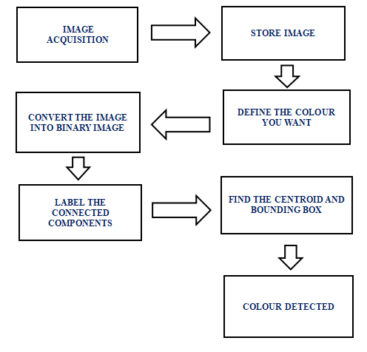

**CIRCUIT DIAGRAM**

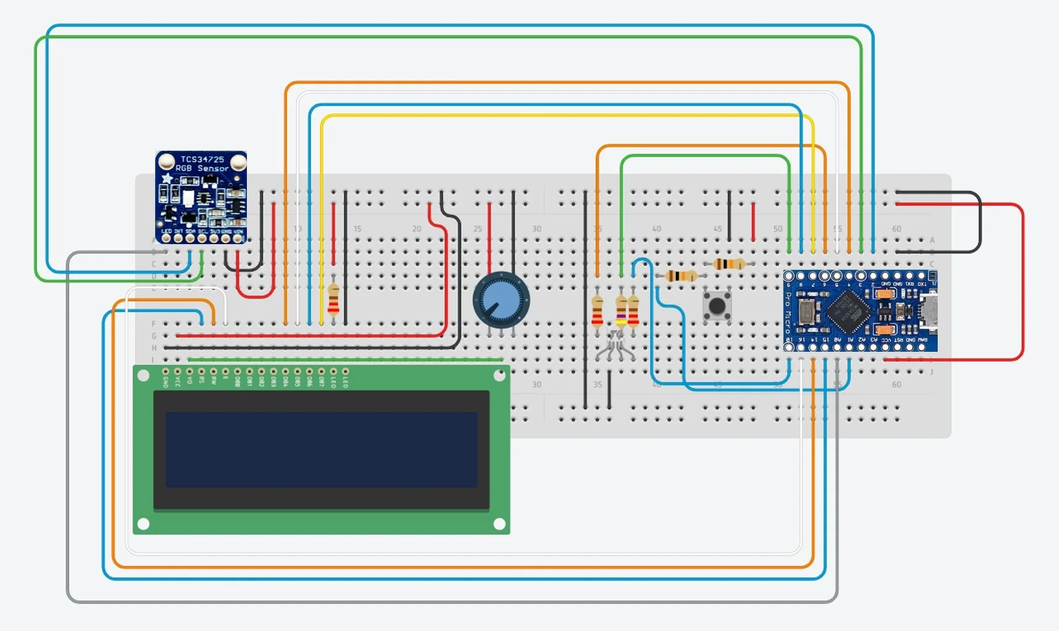

**HARDWARE AND SOFTWARE DETAILS**

**HARDWARE DETAILS**

**Microcontrolle**r: Arduino Board (e.g., Arduino Uno or Nano): Acts as the central processing unit to control the RGB LED and receive input from sliders or potentiometers.

**RGB LED:** Common Anode or Cathode RGB LED: Allows colour mixing by controlling the Red, Green, and Blue components individually. Current-Limiting Resistors (220–330 ohms, typically for each LED channel): Protects the LED from excess current.

**Potentiometers or Sliders:** 3 Potentiometers or Analog Sliders: Used to control each RGB channel (Red, Green, and Blue) independently, providing input to the Arduino.

**Alternatives:** Digital input options like rotary encoders or push buttons, but potentiometers are simpler for continuous RGB adjustments.

**Power Supply:** 5V USB or Battery Pack: Powers the Arduino and LED, ensuring enough current for consistent LED brightness.

**SOFTWARE DETAILS**

**Arduino IDE (Integrated Development Environment):** Used to write, compile, and upload code to the Arduino board. Programming Language: Arduino uses a simplified version of C++.

**Arduino Code for RGB Control:** Code to read the analog values from potentiometers or sliders (0–1023) and map them to RGB values (0–255).

**PWM Output Control:** Control the intensity of each LED colour channel (Red, Green, Blue) using PWM (Pulse Width Modulation) to create different colours.

**Display Code:** To using a display (e.g., OLED or LCD), additional libraries are required such as Adafruit_GFX and Adafruit_SSD1306 (for OLED displays)

**Liquid Crystal (for standard 16x2 LCDs) Functionality:** Code to display RGB values and hexadecimal codes on the screen, updating in real-time as the sliders are adjusted.

**Serial Monitor:** The Arduino Serial Monitor can display RGB and hexadecimal values for testing and debugging without an external display.

**FLOWCHART OF THE CODE**

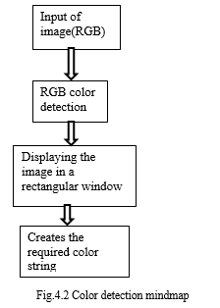

**RESULTS AND DISCUSSIONS**

The project successfully demonstrates the functionality of an Arduino-based RGB colour picker, which includes:

Accurate display of RGB values and hexadecimal codes on connected devices. Wireless control of RGB LEDs using open-source hardware and software. A low-cost prototype offering reliable performance for basic applications, though not as precise as commercial tools.

The accuracy of the system might not match that of commercial colour-detection tools. PWM outputs of Arduino boards may have limited resolution, affecting colour rendering. Primarily designed for educational and low-budget projects, it may not scale well for professional or industrial use without significant upgrades.

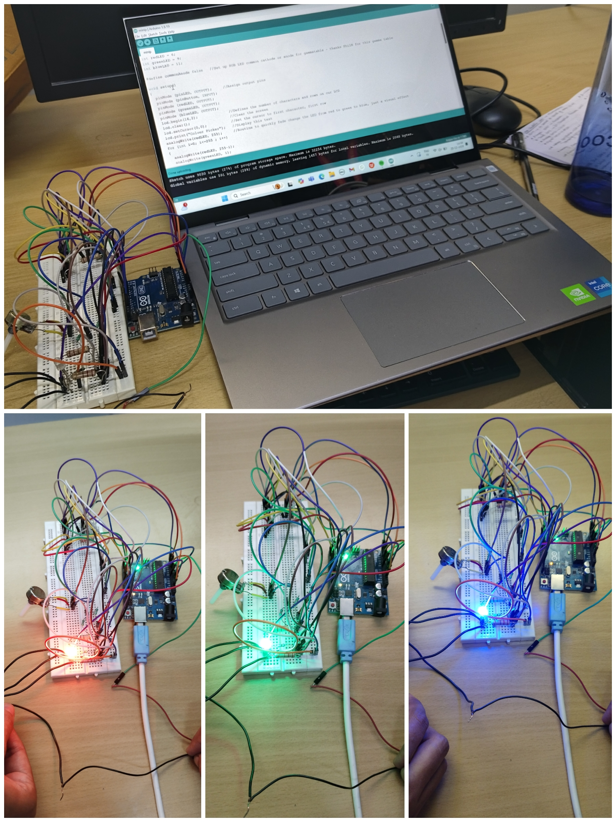

**ADVANTAGES AND LIMITATIONS**

**Advantages:**

Practical Application: Highlights real-world use cases like smart home environments, ambient lighting, and design applications.

Cost Efficiency: Demonstrates how low-cost prototypes can provide a viable alternative to commercial solutions.

Educational Value: Serves as an excellent learning project for beginners in electronics and colour theory, fostering human-computer interaction.

**Limitations:**

Technical Limitations: The accuracy of the system might not match that of commercial colour-detection tools. PWM outputs of Arduino boards may have limited resolution, affecting colour rendering.

Limited Application Scope: Primarily designed for educational and low-budget projects, it may not scale well for professional or industrial use without significant upgrades.

**CONCLUSION AND FUTURE SCOPE**

**Conclusion:**

The project demonstrates a low-cost, open-source RGB colour picker using Arduino, capable of real-time colour detection and representation. It provides a viable alternative to commercial systems for educational and experimental purposes despite minor accuracy limitations.

**Future Scope:**

Improve accuracy with advanced sensors. Integrate IOT for wireless control. Enhance user interfaces and scalability. Expand applications in industries like design and manufacturing.

**REFERENCES**

[1] Wyszecki G & Stiles WS, “Colour science”, New York: Wiley, (1982).

[2] Gonzalez RC & woods RE, “Digital Image Processing”, Addison Wesely Publishing Company, (1992).

[3] Abadpour A, “Colour Image Processing Using Principle”, (2005).

[4] Senthamaraikannan D, Shriram S & William J, “Instrumentation Engineering”, Vol.2, No.3,(2014 ).

[5] Balogh, P., & Horváth, G. (2013) “RGB LED controlled lighting system” (Proceedings Engineering, “Real time colour recognition”, International Journal of Innovative Research In Electrical, Electronics.)

[6] Atzori, L., Iera, A., & Morabito, G. “The Internet of Things: A survey” (2014).

[7] Margolis, M. “Arduino Cookbook”. Monk, S. “Electronics Cookbook”. (2020).

[8] Monk, S. “Programming Arduino: Getting Started with Sketches” (2017).

[9] Badamasi, Y. A. “The working principle of an Arduino” (in Proceedings of 2014, 11th International Conference on Electronics, Computer and Computation) (2014).